**Welding history**

# History of Welding: A Brief History

The invention and technical production of welding is one of the most critical steps in metal fabrication and development as a modern society. The origins of welding date back thousands of years, with significant developments made across many continents. Welding is the original technique for humans to fuse metals together, leading to the production of utensils, jewelry, weapons, transportation, and more.

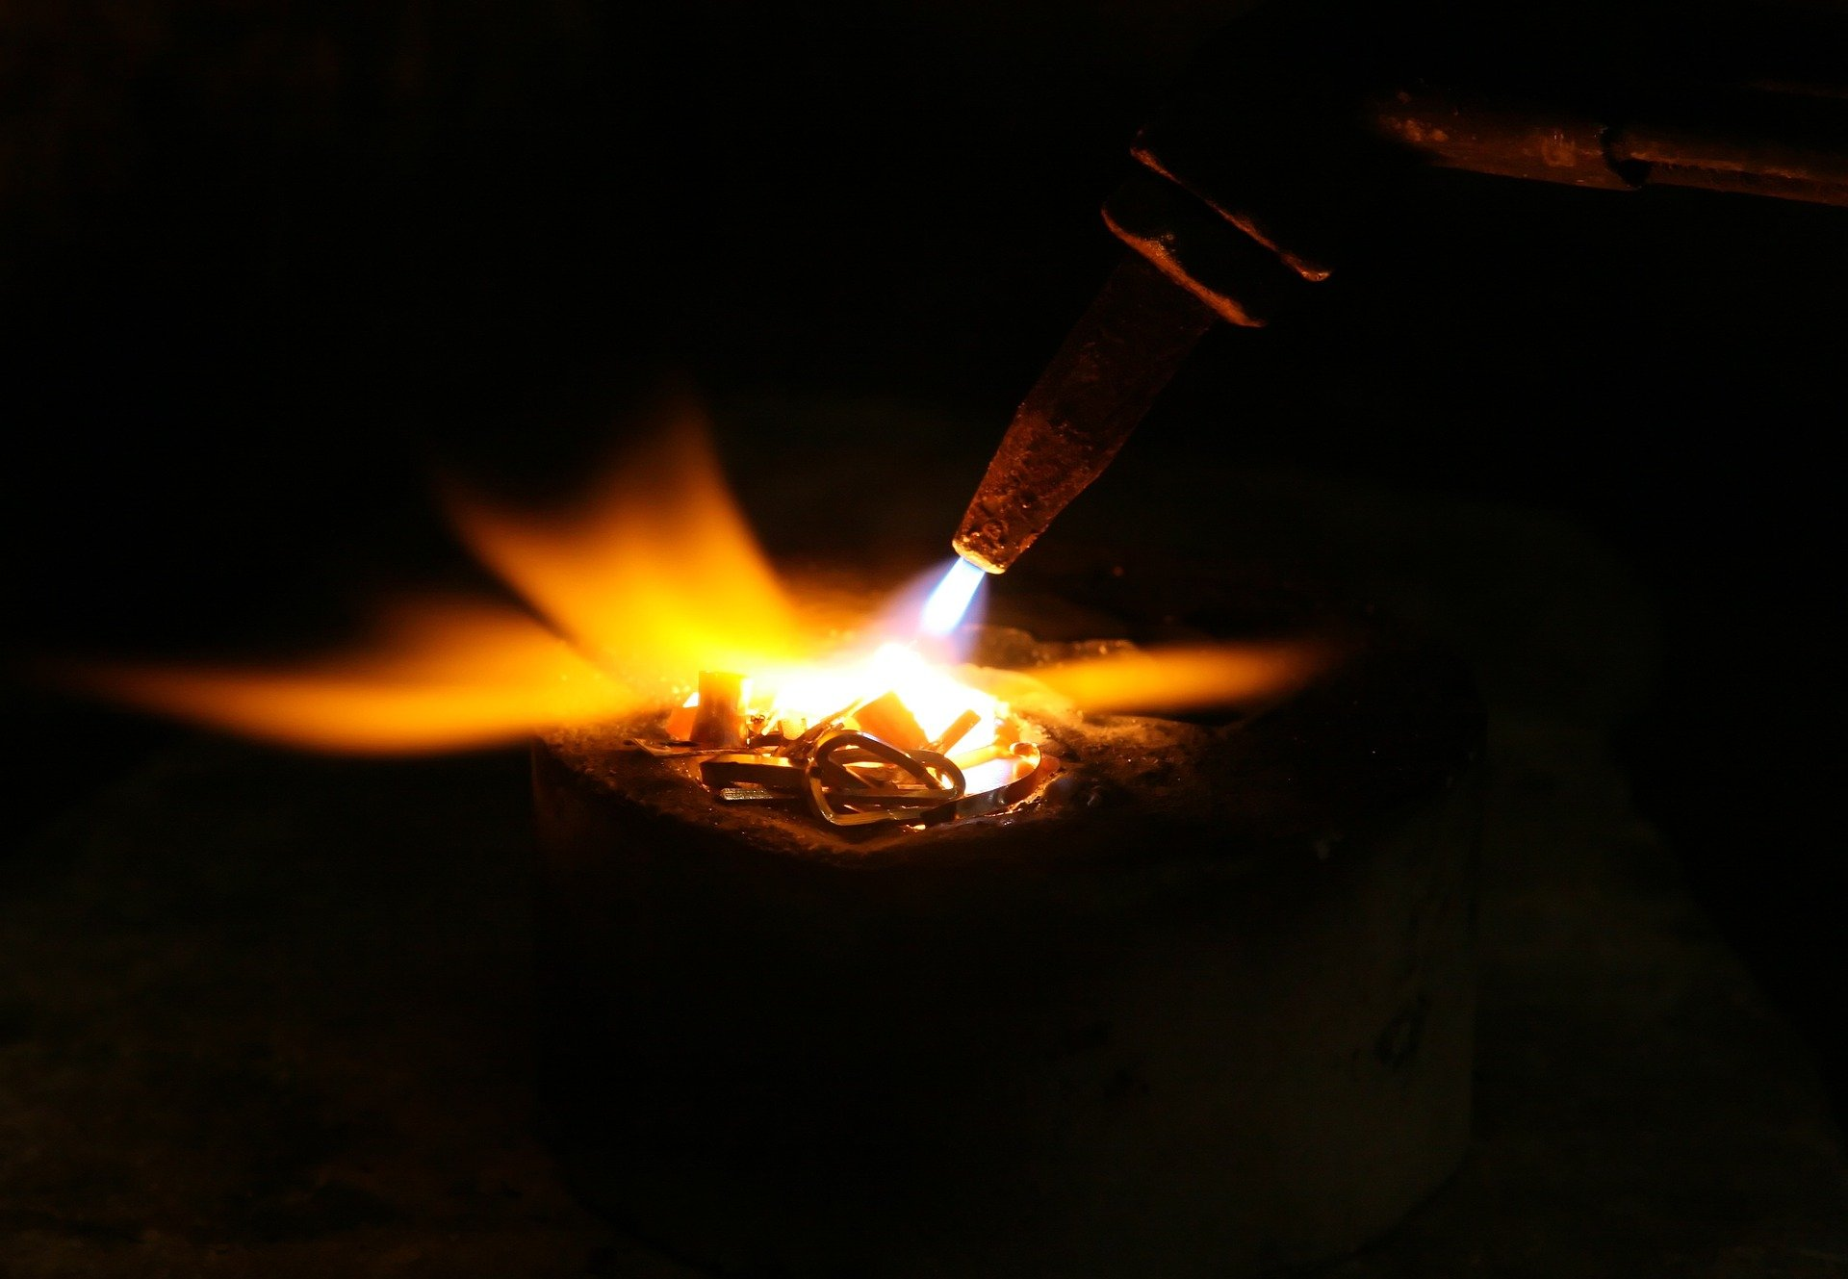

A stinger welding a piece of metal